Appendix 21 – Institute of Life Science – research excellence
The Institute of Life Sciences (ILS)

Excellence in Life Science Research at USAMV Cluj-Napoca

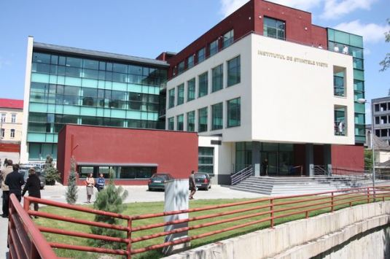
The recently created Institute of Life Sciences (since 2010) is situated in the main campus of the USAMV Cluj-Napoca and represents the best demonstration of the Infrastructure dedicated to „Advanced Research & Specialized Human Resource Development” in our University. It includes the best research resources obtained by our university, during the last 5 years, by our own efforts and performance in Research, Consulting, Service providers and future Technology Transfer.
It is functioning under an integrated approach for advanced (fundamental and applied) research in Life Sciences: Plant and Animal Science, Environmental Protection, Knowledge-based Biotechnology Platform (Including Plant, Animal and Food Biotechnology). It concentrates the most performant and modern equipments which were provided from individual projects of each research group . More than 10 research groups ( belonging to Research Centers or Service laboratories) are located in more than 40 different laboratories, at different levels of the Institute.
The total surface of the Institute is of more than 4200 sq meters, and includes at the Ground Floor the Doctoral School Office, the Postdoctoral School Office, The IT department, The Longdistance learning department, 2 amphitheaters with updated facilities for International Conferences, as well for for PhD presentations.
Floor No. | Research field /Centers/Platforms | Accreditated /service laboratories | Coordinators
I | AGRICULTURE-PLANT SCIENCE AND ENVIRONMENTAL PROTECTION | Laboratory for tests concerning water and noise level - LIAZ | Tania MIHĂESCU, PhD, Lecturer
I | AGRICULTURE-PLANT SCIENCE AND ENVIRONMENTAL PROTECTION | Laboratory for air quality analysis - LACA | Ioan Oroian, PhD, Professor
I | AGRICULTURE-PLANT SCIENCE AND ENVIRONMENTAL PROTECTION | Zone Laboratory for certifying the feed quality - LZCF | Antonia ODAGIU, PhD, Lecturer
II | ANIMAL SCIENCE AND VETERINARY MEDICINE | Laboratory for the quality control of apiculture products - APIS | Liviu MĂRGHITAȘ, PhD, Professor
II | ANIMAL SCIENCE AND VETERINARY MEDICINE | Regional laboratory for apiculture control and diagnosis – LR-CDA | Liviu MĂRGHITAȘ, PhD, Professor
II | ANIMAL SCIENCE AND VETERINARY MEDICINE | Laboratory for the certification and cryopreservation of animal germoplasma - LCCG | Vasile MICLEA, PhD, Professor
II | ANIMAL SCIENCE AND VETERINARY MEDICINE | Regional Laboratory for genotyping farm animals - LZGA | Augustin VLAIC, PhD, Professor
II | Research Center for supervision, diagnosis and zoonose control |  | Vasile COZMA, PhD, Professor
III | BIOTECHNOLOGY | Laboratory for Agrifood quality and authenticity - AGRIAL | Carmen SOCACIU, PhD, Professor
III | BIOTECHNOLOGY | National, reference laboratory for the evaluation and conformity certification for vegetal origin products that contain GMOs - CERTOMG | Doru PAMFIL, PhD, Professor
III | KNOWLDEGE-BASED BIOTECHNOLOGY PLATFORM |  | Doru PAMFIL, PhD, Professor
III | Research center for Molecular markers |  | Doru PAMFIL, PhD, Professor
III | Research center for Chemistry and Biochemistry of Plant Pigments |  | Carmen SOCACIU, PhD, Professor

The Human Resources in ILS are represented by more than 25 postdoctoral fellows and more than 50 PhD students who are working for their own research projects as well for different research projects developed in the above-mentioned centers and laboratories.

KNOWLEDGE-BASED PLATFORM OF BIOTECHNOLOGY
The activities related to this unique platform in our university are complex and include: research – teaching - innovation and technology transfer, services and consultancy. A special role is attributed to PhD and postdoctoral schools which are developing their programs in this infrastructure, following research topics related to all biotechnology areas (1 to 6), as presented in Annex 1, below.
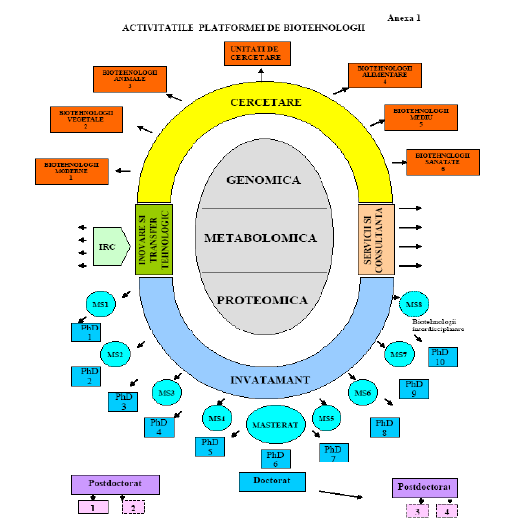

The research topics are related to genomics, metabolomics and proteomics, with involvement in the green /white/red and gray biotechnology, with impact in agrifood areas, as well environment, industry, nmedicine and pharmacy (see Annex 2, below).

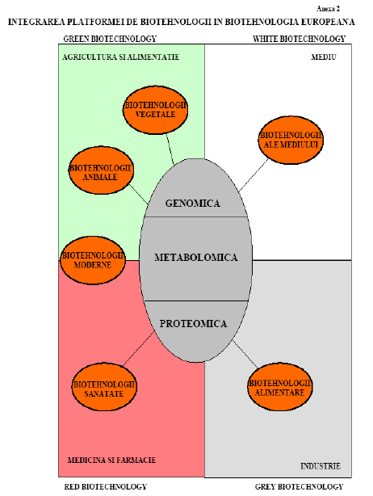

The Biotechnology Paltform is connected and integrated also to European Technological Platforms, as presented below (Annex 3)
