Appendix 5 – Geographic position

USAMV Cluj-Napoca campus maps
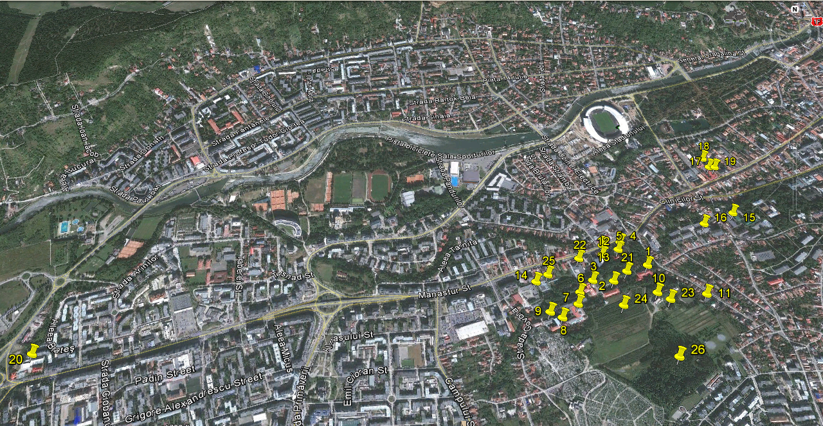

Maps legend:

- Rectorship building
- Faculty of Horticulture
- Mihail Şerban Hall
- Soil science Department
- Library
- Faculty of Veterinary Medicine
- Veterinary Hospital
- Infectious diseases Clinic
- Faculty of Animal Science and Biotechnology
- Research Center for Biodiversity
- The Sports Hall and ground
- Building under construction (The New Library)
- The Biotechnologies Department
- Mechanization Department
- Students’ Hostel No. VIII
- Students’ Hostel No. XII
- Agronomia Restaurant
- Agronomia Students’ Hostel
- Agronomia Pub
- Technology of Agri- Food Processing Department
- Students union
- Life Sciences Institute
- Botanical Garden
- University’s Orchard
- University’s Greenhouses
- University’s Forest

The teaching process premises (map detail)

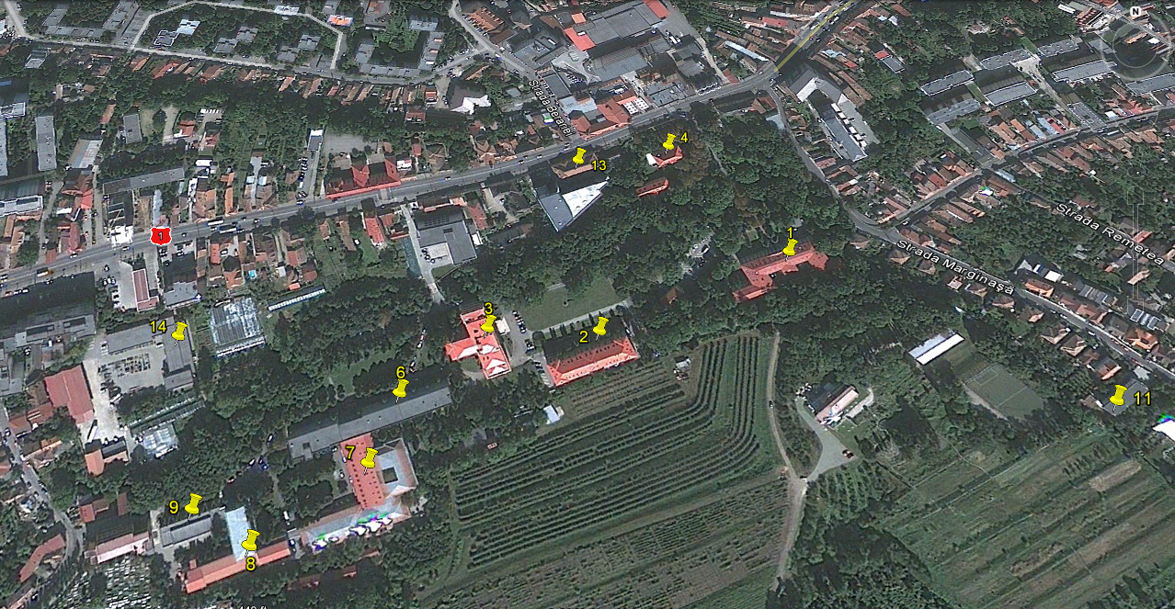

Students’ Hostels (map detail)

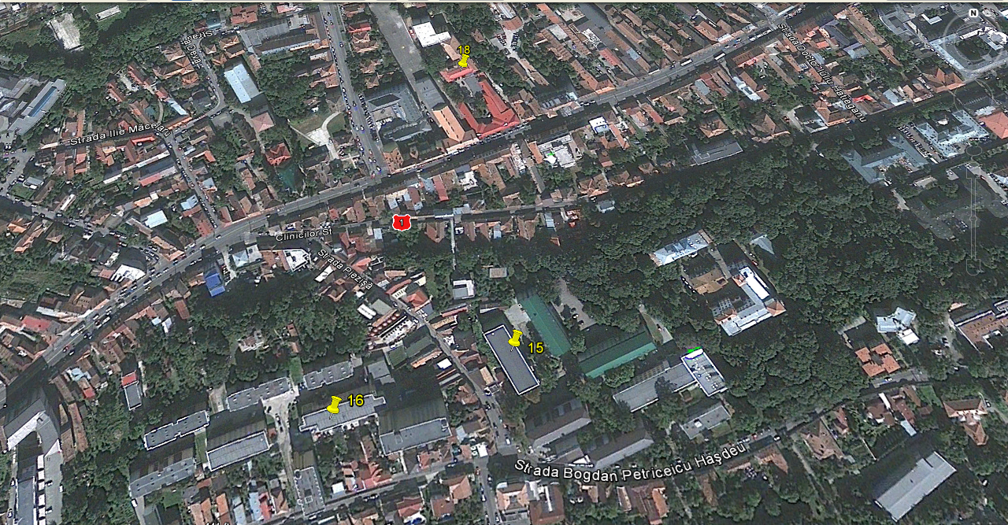

Students’ facilities (map detail)

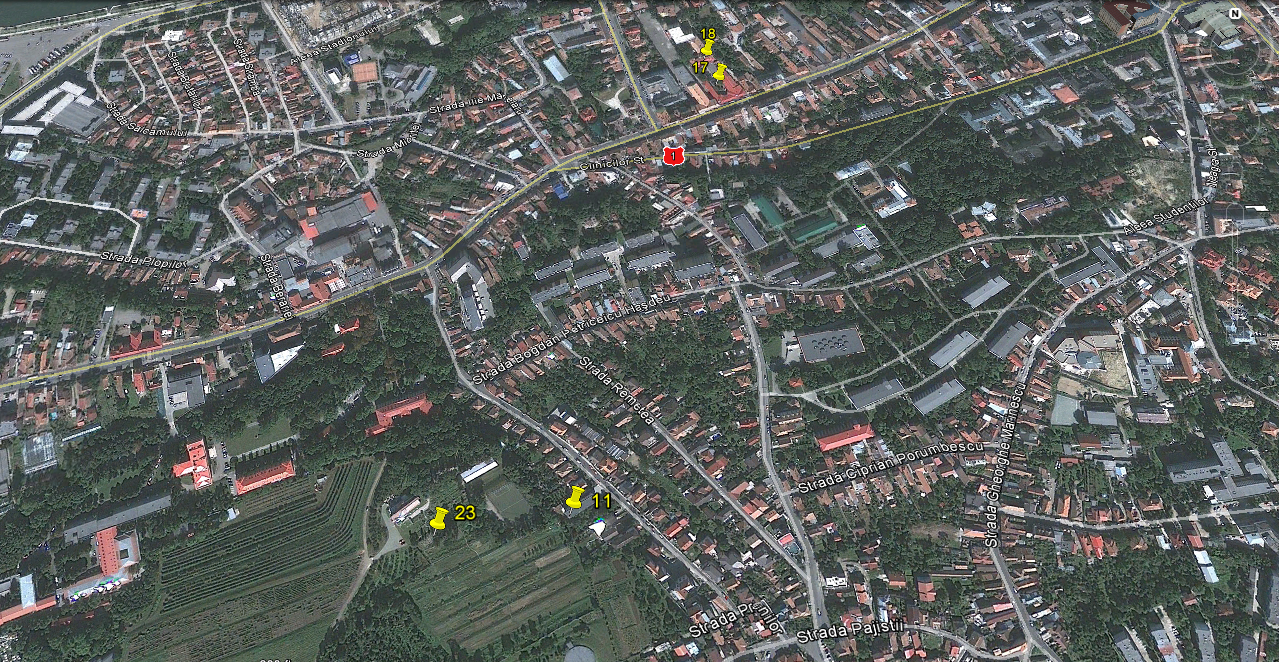

The Teaching and Research Station – Mănăștur area

The Teaching and Research Station – Cojocna area

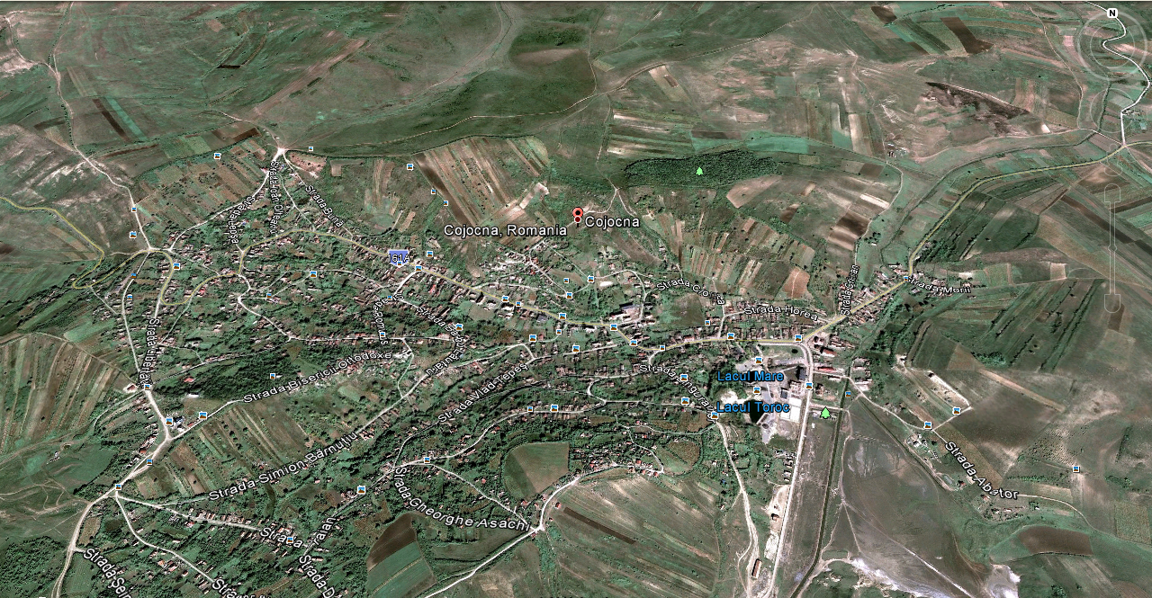

The Teaching and Research Station – Jucu area

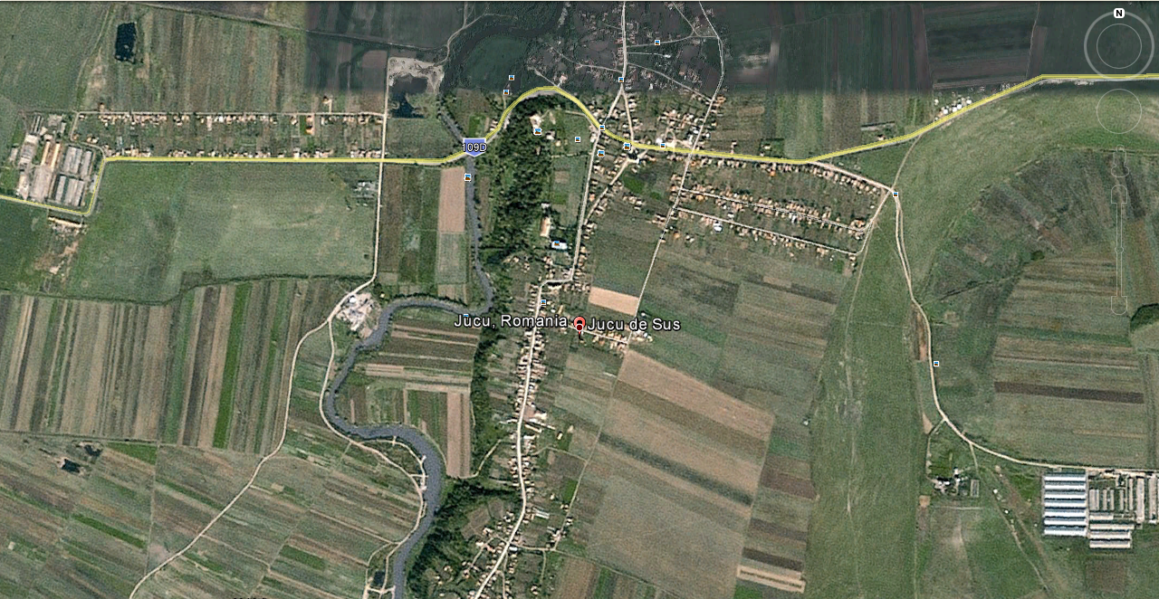

The Teaching and Research Station – Palocsay area

